2021 Connecting Space Regions
Save the Date
Go Space: Small Pads, Small Launchers, Small Sats
European infrastructure for access to space
Tuesday, September 14th, 2021, (02:00 PM to 03:30 PM CEST)

Dear members and network partners,
Are you interested in getting to know more about the latest developments regarding Launch Pads, Micro Launchers and Small Satellite companies in Europe? Then, join the Connecting Space Regions Networking Series on Tuesday September 14th, 2021 between 02:00 PM and 03:30 PM on the topic of
Go Space: Small Pads, Small Launchers, Small Sats
Presentations are expected from:
- ESA ESTEC: European Space Research and Technology Centre (Franco Ongaro, Director of Technology, Engineering and Quality (D/TEC), and Head of ESTEC in Noordwijk, the Netherlands)
- German Offshore Spaceport Alliance GmbH (Andreas Stamminger, Business Development - Access to Space)
- ISIS – Innovative Solutions In Space (Jeroen Rotteveel CEO and Co-founder)
- S3 Platform Space (Karin Holmqvist, Head of Innovation Program Strategy Swedish Space Corporation)
The event will be moderated by Ludger Fröbel (AviaSpace Bremen) and Q&A after every presentation for interaction with the audience.
Company pitches from the micro launcher and Small Sat domain will provide you with an overview of the companies’ activities and new developments in the sector. There are still some spots available for your company pitches. So, if you are a company in the micro launcher or Small Sat domain – please do not hesitate to contact us for a pitch slot!
Register under the following link for the event and pre-schedule business meetings with representatives from space institutions and companies located in Zuid Holland, Bremen and across Europe.
By registering, you can set up your profile and send out your meeting requests right now. Use the Connecting Space Regions platform to expand your global network and individual B2B contacts!

About Connecting Space Regions Event Series:
The event series “Connecting Space Regions” aims to foster international cooperation in the area of aeronautics and space and is comprised of official keynotes, presentations and/or panel discussions. A unique longterm B2B matchmaking tool by the Enterprise Europe Network (EEN) enables participants to expand and foster their business contacts well into the year 2022. Target audience are representatives from aeronautics and space institutions and companies (research, business & startups).

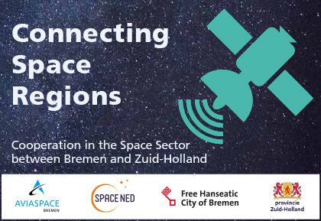

About the S3 Platform on space: value chain access to space
The European Commission (DG Regio) recently accepted the application for Expression of Interest for starting a S3 Platform Space (the region of Norrbotten acts as coordinating region). The S3 Platform on space is on the verge of starting.

Industrial modernisation requires important investment efforts. The regional Smart Specialisation Strategies (S3) helps to prioritise and align efforts between public and private stakeholders in EU regions and allocate EU and regional funds in a focused and efficient way. At the same time, there are clear opportunities to engage in strategic interregional cooperation along shared S3 priorities in order to complement each other’s competences, share infrastructure, and develop joint investment projects. Such interregional cooperation will allow scaling up towards larger impact and more effective collaboration along industrial value chains.

S3P Space is part of the Smart Specialisation Platform for Industrial Modernisation (S3P-Industry) which aims to support EU regions committed to generate a pipeline of industrial investment projects following a bottom-up approach - implemented through interregional cooperation, cluster participation and industry involvement.
https://s3platform.jrc.ec.europa.eu/industrial-modernisation

