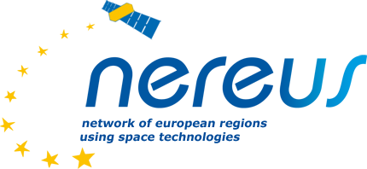

NEREUS AISBL Adhesion Form

We, , request to become a member of NEREUS AISBL.

To this end we commit to sign the “Political Charter” and the “Statutes” of the Association and to contribute to the functioning cost of the Network:

The annual subscription fees are:

Full Members^{i}: € 10.000/annum

Associate Members^{ii}:
Companies with more than 250 employees: € 7.500/annum SMEs with less than 250 employees: € 1.500/annum
Local Authorities University, Research Centres, non profit organisations and SMEs with less than 50 employees: € 750 eur in 2024 /annum

In order to register your application correctly please supply us with the following information:

- Full members:

- Name of the region: ………………………………………………………..............
- Official Address: ………………………………………………………………….....
- The region is represented by Mr/Mrs at the General Assembly.

Signature:

(Done by the responsible administration)

- Associated members :
- Name of the organization………………………………………………………….
- Official address:…………………………………………………………………….
- Region: ……………………………………………………………………………...
- Member State: ……………………………………………………………………...
- Official contact person: …………………………………………………………….

Signature

Contact details of official contact person: Name:……………………………………………………………………………………..
Telephone:………………………………………………………………………………..
Fax:………………………………………………………………………………………..
Email:……………………………………………………………………………………...

For our own internal use we kindly ask you to answer to the following question:

How did you find out about NEREUS?
Nereus Members Networking Internet
Events Other

After the approval of your membership by the General Assembly, you will be officially invited to pay your annual fee to the following account:

KBC BANK NV/SA/AG
Havenlaan 2 / Avenue du Port 2 1080 Brussel / Bruxelles Compte d’entreprise KBC
733-0506144-28 NEREUS
IBAN BE37 7330 5061 44 28 BIC KREDBEBB

For any further information, please contact: NEREUS (AISBL) – Secretariat
Roya Ayazi (Secretary General) rayazi.nereus@euregions4space.com

Margarita Chrysaki (Communication/Project Officer)

Mchrysaki.nereus@euregions4space.com

c/o Representation of the State of Hessen to the EU 21, Rue Montoyer
B-1000 Brussels Tel. : 02/ 7347649
Website : www.nereus-regions.eu

i Full members are regions or territorial entities, herewith formally acknowledge as “regions”, from EU Members States, with a measure of autonomy existing on the next level after the State and endowed with an independent political representation. Full members have the right to vote at General Assembly meetings and may be elected to the Management Board via the representatives designated by themselves.
ii Associate members are local authorities (other than regions), companies, corporations, research institutions, associations, foundations, universities, firms, networks, etc. Associate members are allowed to participate in all working group meetings and to take part to the General Assembly meeting in a non-voting capacity

