## A Martian canyon has been spotted in Krakow

Thanks to a weeks-long effort by planetary geologists, logistics experts and organizers, a several-hundred-ton structure measuring nearly 900 square meters was created, which will be the arena for the struggles of teams participating in this year's ERC. The event is making its debut in Krakow and will take place September 6-8 at the AGH University of Krakow.

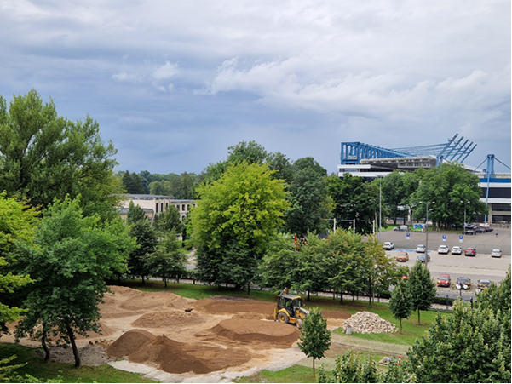

***In previous editions, we were inspired by northern locations on Mars, especially those where Mars mission rovers landed. This year we have moved to a completely different location and will be working on the surface of Valles Marineris, the largest canyon in the Solar System, measuring as much as 4,000 km long, 8 km deep and up to 400 km wide. It's a gigantic geological structure and one of the most interesting places on the Red Planet, especially in terms of research and its future, since it's a potential location for building a future Martian base*** – mentions Dr. Anna Losiak, a planetary geologist and lead designer of the ERC’s Marsyard.

Link to more information about Marsyard - <https://roverchallenge.eu/a-martian-canyon-has-been-spotted-in-krakow/>