**EUROPEAN ROVER CHALLENGE**

STEM EXHIBIT & INSPIRATION ZONE

Step into the ERC Inspiration Zone, where the future of space exploration comes alive! It’s not just a peek – it’s a hands-on adventure into the fantastic world of space and STEM! Visit Exhibitor fair, take part in workshops, and conduct scientific experiments.

Link - <https://roverchallenge.eu/stem-exhibit-and-inspiration-zone/>

Through interactive exhibits, educational workshops, and insightful discussions, visitors are not only entertained but also encouraged to explore the vast and exciting world of STEM disciplines. This commitment to STEM education aligns with the ERC’s overarching goal of inspiring and empowering the next generation of scientists, engineers, and innovators.

## What to expect?

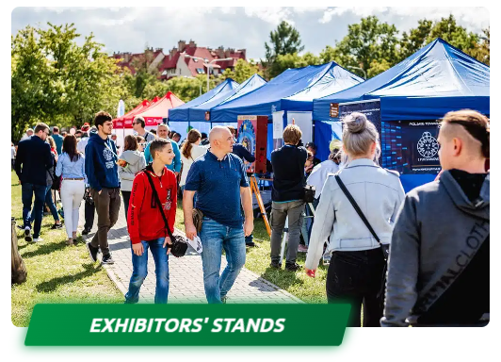

Dozens of exhibitors, ranging from commercial companies in the space industry to leading universities and science clubs, come together to present their products, experiments, and science exhibits.

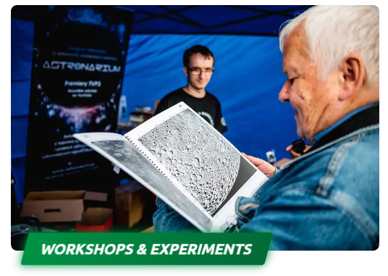

Science clubs, associations, and STEM foundations add an interactive touch, providing hands-on activities and captivating demonstrations for visitors of all ages and backgrounds. It’s a chance to learn by doing, fostering a deeper understanding of science and technology.

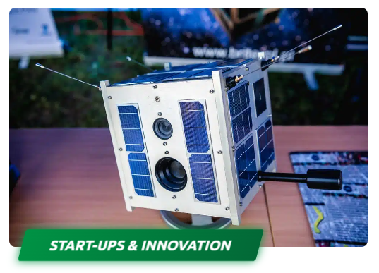

The ERC is a fertile ground for start-ups and innovators in the space sector. Engage with these creative minds and nurture connections and dialogues that could pave the way for future partnerships.

**Get inspired by space!**

**The Inspiration Zone is a haven for curiosity seekers, offering something for everyone, regardless of age or level of space passion.** This vibrant space celebrates innovation, featuring diverse products, experiments, and science exhibits that showcase the forefront of space exploration and technological advancements. You can also engage with researchers and students, pushing the boundaries of our understanding of the cosmos. The ERC Inspiration Zone bridges academia and the public, fostering an environment where knowledge is shared and curiosity is sparked.